Booking form for schools and visiting groups 2020 UK RESIDENTS ONLY
Please complete this form and email to: education@exeter-cathedral.org.uk
For further info please phone us on Education on 01392 345887 or visitors on 01392 285983
Date of Visit |  |  |  | *Please let us know if you think you will need 15 mins toilet time on arrival or if you will be ready to tour on arrival.
*Arrival Time:
Departure Time:
Please take into account the distance you are coming – we do not want you to lose your tour time slot!
Contact name:
Name and Address of School:
Telephone Number:
Email Address:
Type of Visit:  Delete as appropriate | Cathedral entry only £1.50 / Guided Tour £2.50 / Activity £2.50 / Talk £3.00/*Roof Tour £5/Tower Tour £3.50 / Other /Talk and Tour on a theme£3 /Booklets 20p each  St Nicholas Priory - Cathedral Day £6
Tour Theme:  Delete as appropriate | General / Signs and Symbols / A Special Place / Medieval Building / Art in the Cathedral / Easter / Christmas Themes/ WWII / Pilgrimage / Tailored Tour Theme
Activity options | Brass Rubbing / Stained Glass Shrinkie Keyring Design / Heraldry Design / Murder in the Medieval Cathedral / Paint Glass Votive Candles Holders / Mini Model Medieval Workers
Cost per pupil: | £ | Number of Pupils:
Age of pupils: |  | Number of Adults:
Name of Group Leader: |  |  |  |  | * Please let us know if you require a snack time in-between tours, so that we can allow for this when booking our guides.
Any Special Needs Requirements:
Payment: | NB. You will be invoiced before the visit. If there are any extra participants on the day, a separate invoice will be raised after the visit.
How did you hear about us?
We will ask for feedback after your visit, we would be grateful if you would reply so that we can endeavour to make your experience as successful as we can now and in the future! If you have an issue with your experience at the Cathedral, please tell a member of the Education Staff on duty or Email us ASAP after your visit. We hope you have a great visit!
Due to the capacity of our room space, we are unable to offer a lunch room for free. We can offer a space, where available, for a charge of £15 for up to 35 pupils for half an hour or £30 per hour. This package is for Cathedral Visitors only. If you would like to use our lunch room and toilets without a Cathedral visit, the room is charged at general room hire rates, approx. double the quoted cost.
*Roof and Tower tours strictly for children over the age of 8 and separate rules apply.
OFFICE USE ONLY
Timetable for the day:
Rooms Booked: |  |  | Guides Booked:
Please note:
1. Exeter is a working Cathedral and services can take place at very short notice. If your visit will be affected we will contact you as soon as possible to rearrange your visit. NB. Concert rehearsals often happen.
2. Most of our guides are volunteers who give up their free time to provide tours. Guides are booked specifically for pre-arranged tour times and will wait up to 20 minutes for parties who are delayed.
If you anticipate that you will be late, please contact the Education Office on 01392 345887. If you are over 20 minutes late and we have received no message from you, then we cannot guarantee that your tour will take place - we will offer you the option of a self-led visit instead. If a booking is cancelled less than 48hrs before a visit, please note that we will have to charge 60% of the whole visit, less than 24hrs, 100%. Cancellations must be made via email AND phone.

It helps if you can prepare your pupils for the visit – especially if you are having a self-led tour, conduct in the Cathedral is very important in the way you and others use the building.
Remember that the Cathedral is primarily a place of worship. The building itself and the ceremony of the building needs to be respected.
- On the hour a duty chaplain will say prayer for visitors. Please stand still and quiet for a couple of minutes at this time, so others can pray.
- Please no food or drink in the Cathedral.
- Pupils must walk around with a designated adult.
- You are more than welcome to use the cathedral toilets – please get a code form the Welcome Desk.
- The benches in the cloister area are reserved for café customers, you can sit on the grass or out on the cathedral green if you would like.
- Candle lighting must be supervised by an adult.

If you have any questions, do contact us, we are happy to advise you.

We hope you have a great visit with us.
Exeter Cathedral Education

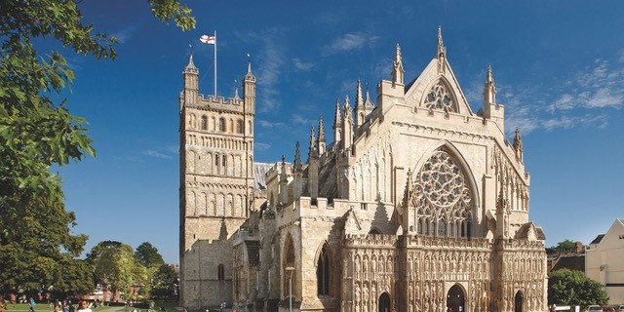
Exeter Cathedral Heritage
It is not widely known that maintaining such a significant building as this comes with a hefty price tag. The Cathedral’s running costs currently amount to over £6,000 per day, with no regular assistance from government or funding from the Church of England. This is why we currently have to ask visitors for an entrance charge to help keep the building open. Our hope is that in the future this charge will be waivered in favour of donations.

Data Protection
The information that you provide on this form will be held by Exeter Cathedral to enable us to process your booking. The data will be stored on a secure computer system and used to administer the booking, and will be destroyed as soon as it is no longer required.
The details you provide will only be used by Exeter Cathedral. We will never swap, share or sell your information to a third party.
You can ask to be removed from our records at any time by emailing education@exeter-cathedral.org.uk or by writing to the address above.
Our Privacy Policy gives more detail of how we use and protect your information. You can view it at www.exetercathedral.org.uk/privacy or ask us to provide you with a copy.

