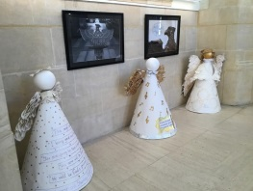
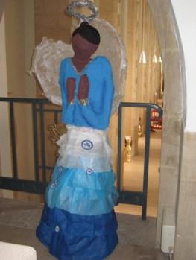
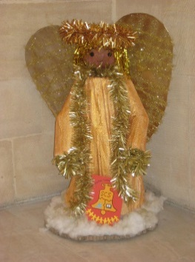
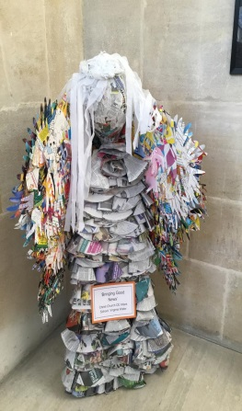
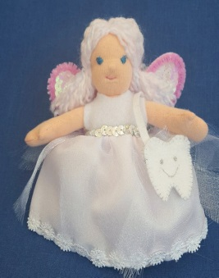
Angel Art Exhibition Dec 2019
We would like to invite your school / college to take part in our Model Angel Exhibition that will be held in Exeter Cathedral in December 2019.
Exeter Cathedral Education Department plan to display model angels throughout the Cathedral that have been created by small groups, individuals or class groups of all ages. It is a great opportunity for a group or class project, to design and make in a medium of your choice. It doesn’t have to be a Christmas Angel, so you can start well ahead of time.
There will be an opportunity to view the Angels on our Special Service Day of Friday 6th Dec. There will be an Advent Angel celebration service at 11 – 11.45am. We will also be offering groups a guided tour, either before, or after the service on the theme of ‘Angels of the Cathedral’ - where they will have an opportunity to spot their creation on the way around.
The exhibition launch date will be on Sat 30th November, from 1.30 - 3. 30pm. We are holding a free family fun afternoon of angel-themed crafts - which anyone is welcome to attend. Otherwise, your school / college can arrange to visit the Cathedral to see the exhibition from 2nd Dec - 4th the January. Our hope is that participants will encourage family members and friends to come and see their angel creation over the Christmas holidays. Should your group not be able to visit, we will send a photo of your Angel in situ!
Please have a look at the example angels on this flyer for ideas. You can use any material, but preferably keeping the weight of your angel as manageable as possible to carry. You may decide on one large angel representation or a host of smaller ones, with whole participation or just a select group. Our Cathedral Departments like the stonemasons, tapesers, flower arrangers etc. will also be adding to the exhibition for pupils to spot.
We would love as many schools and colleges as possible to be a part of the exhibition and hope that Cathedral visitors will appreciate the efforts of local students and their teachers.
If you feel that this project is for you and you would like your school / college to participate, please email Lisa on lisa.gordon@exeter-cathedral.org.uk , I will send you more information and an application form.
Best wishes,
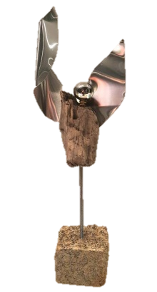
Lisa Gordon
Head of Cathedral Education
