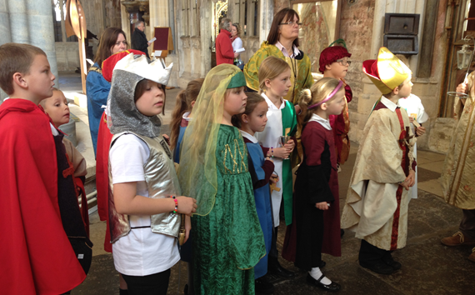
Pilgrim Days
Schools Information Pack
Primary School Yr6 Pilgrim Days
Mon 24th, Tues 25th and Wed 26th June 2019
This pack has been put together to support Yr6 Class teachers in preparing their children for the visit to Exeter in June. Please read carefully and contact Lisa Gordon with any enquiries;
Lisa Gordon, Head of Cathedral Education, 1a The Cloisters, Exeter, EX1 1HS
Tel: 01392 345887
E: education@exeter-cathedral.org.uk
W: https://www.exeter-cathedral.org.uk/pilgrim-days

Contents
Context, Aims, Vision & Values page 3
Planning group page 4
Booking and cost page 4
Format of the day page 5
Locations page 5 - 6
Workshop information pages 6 -9
Worship information pages 9 – 10
General information pages 10 - 11
Risk assessment pages 12 – 13

Context
Pilgrim Days are a very special event in the life of children in the church schools that we serve. They give the opportunity to bring together children, staff and volunteers from church schools with other schools they are working with. Through worship, workshops, song and prayer we celebrate their journey so far and think about the next stage in their journey through education and indeed, life. We believe it is a joy to bring children together to worship in this sacred place.
This being the first year we are offering Pilgrim Days to year 6 pupils, we will endeavour to make it as relevant as we can and will be happy to receive feedback after the event. It is also our aim to make the Pilgrim Days as accessible to as many of the diocese church schools and other local schools, as possible. (Should you have a mixed year group and want to bring other year groups along to make the trip worth your while, then please do).
We hope that you will be able to join us in June to experience this celebration of moving on and exploring the theme of ‘Pilgrimage’. This booklet sets out for you our aims and vision as well as and useful information that you may need in preparation for your Pilgrim Day.
Aims
- To gather together children and staff from our local school family to celebrate their school experience and send them on the next stage of their journey.
- To celebrate God’s love and care for them now and in the future.
- To acknowledge the rite of passage moving on to the next phase of their education.
- To welcome children and staff from our school communities to worship together in their cathedral.
- To look back, be thankful and celebrate and also to look forward with hope.
- To encourage children to mix and work with other children and adults to help them prepare for the next stage of their journey.
Vision & Values
‘That they may have life, life in all its fullness.’ John 10:10
What we value about Pilgrim Days
- Celebration
- Journeying
- Welcome
- Thankfulness
- Belonging
- Fellowship
- Worship
- Partnership

Planning Group
Lisa Gordon Head of Education, Exeter Cathedral
John Searson Diocesan Director of Education
Sue Lockwood Diocesan Deputy Director of Education
Tatiana Wilson Projects and Vulnerable Pupils
Katherine Lyddon Diocesan Children’s Ministry Adviser

Booking
Booking will be done via an online form on the Pilgrim Days webpage. There are 250 - 300 places available each day. If there are not enough places left for your party on your first choice of day, we will let you know and offer you an alternative day. Once you have completed the online form you will receive a confirmation email of your booking, you can then go ahead and book transport etc. Pupil allocation to workshops and extra details will be finalised with you once the booking forum has closed in March.
Cost
The cost is £8 per child. This is to cover the cost of venues, workshop leaders and resources. You will be invoiced for the number of children booked. If this number increases you will receive a further invoice, if it decreases we are unable to offer refunds so please make sure you book for the correct number of children. There is no charge for accompanying adults.

Format of the day
Below is an outline of the timings of the day. Throughout the day you will be welcomed and supported by staff and volunteers from Exeter Cathedral and the Diocese. In order to ensure the day runs smoothly, please can we ask that you arrive in plenty of time to register and be seated ready for worship to start at 10am.
09.40am Welcome and registration

Please can one adult come to the registration desk on arrival with information about alterations to numbers or groups and can the children and remaining adults take their seats in the nave of the Cathedral.

09.55am All seated in the Cathedral
10.00am Opening worship
10.15am Group Helper will lead you to your 1st workshop
10.25am Workshop 1
11.15am Group Helper will lead you to your 2nd workshop
11.25am Workshop 2
12.15pm Lunch

This will be either on Cathedral Green (just in front of the Cathedral), the Cloisters to the side or in the room where you had workshop 2 depending on the weather. You will be notified during the opening worship what the lunch time arrangements are and your group leader will take you to the allocated lunch spot. Please make sure that each child has their own lunch with them or that each adult with a group has all the lunches for that group.

1.05pm Gather back in the Cathedral nave ready for closing worship
1.15pm Closing worship
2.00pm End and depart
Please book coaches for 2.15pm.

Locations

During these days you will be based at Exeter Cathedral and also some groups may attend workshops in the St Nicholas Priory, Devon and Exeter Institution, the Diocese Garden, the Cathedral Green and The Library and Archives. Coach drivers use drop off points on South Street, which is convenient for the Cathedral otherwise parking in the city car parks. If you are travelling by mini-bus, we may have room for you to park in Place Gate, this is very limited, if you need information about this please ask. Group Helpers will lead your groups between worship and workshops, so you don’t need to worry about finding where you need to be.
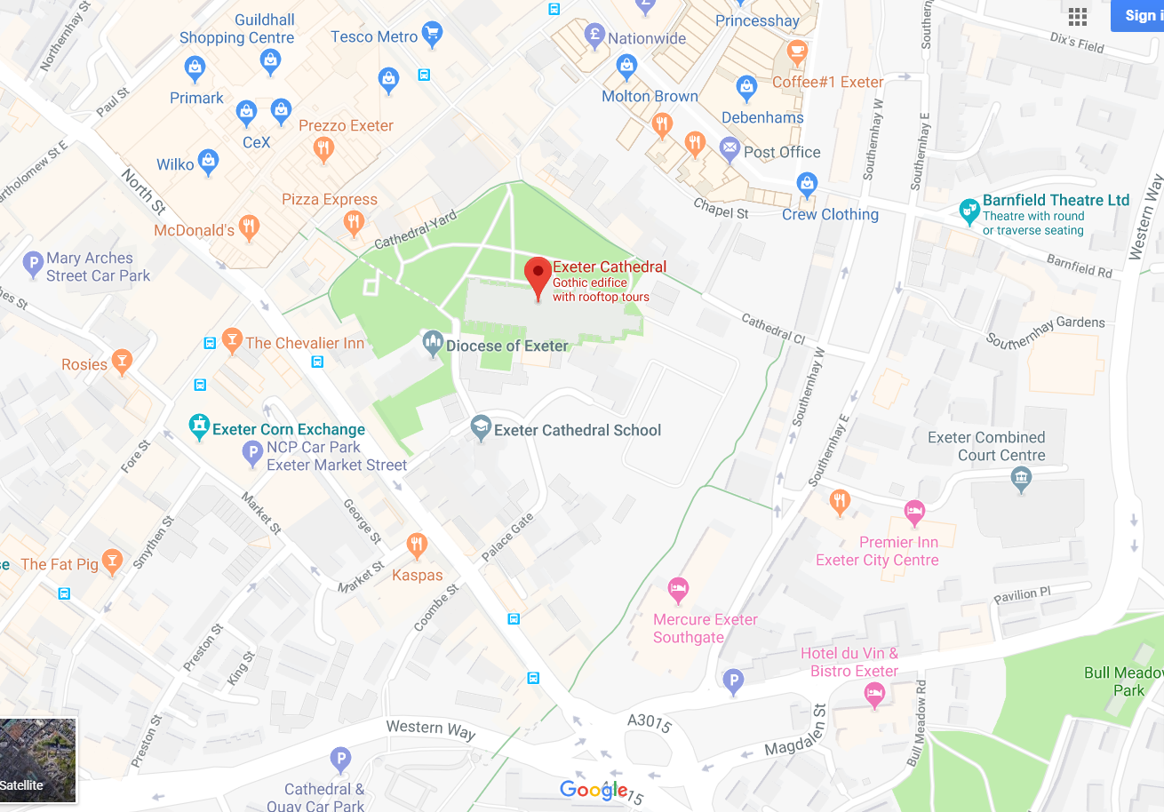
Devon and Exeter Institution St Nicholas Priory

Workshop Information
All children will take part in two, 50 minute workshops.
Once all the bookings have been taken and schools allocated to days, we will notify you which group/s your children are in and which workshops they will do. In order to help us to do this, please can you ensure you indicate on the booking form any special educational or physical needs we need to take into consideration. We will then ask you to fill in a form and tell us which children are in which groups so that on the day, we can easily find a child or adult at any given time if necessary.
Each adult that you book to attend with be allocated a group of children from within your school so for example, if you book for 20 children and 4 adults, we will split your children up into 4 groups with 1 of your adults in charge of that group. For this reason it’s important that you accurately book the correct number of adults. Each adult will be allocated a number of children from your school only to be responsible for, please make sure that all adults are comfortable looking after a small group of children

Yr6 Workshop Groups
Group No. | Workshop 1 | Workshop 2
Group 1 | Document your past - Archives | Please see email for the choice of workshops that we are offering your school for their session this year.
Group 2* | Pilgrim Designers – Shrinkies Pearson
Group 3 | Time Travellers - Priory
Group 4 * | Book Detectives - DEI
Group 5 | Cathedral – Pilgrims Trail
Group 6 | Orienteering - Cathedral Green
Group 7 | Brass Rubbing Montage
*Suitable for wheelchair users as these workshops take place on ground floor, accessible rooms or have lift access.
Workshops may change a little from what is written here depending on number of children attending on the day. Either way, the workshop offered will be fun and informative.
Workshop | Location | Content & Learning Outcomes
Cathedral – Pilgrims Trail | Cathedral Nave | Exploring the Cathedral dressed in pilgrim clothes or cloaks, children experience being on a journey as they go around. Children will play their part within the tradition of pilgrimage and gain an insight into the cultural heritage of the building. Each child takes home a shell box as a souvenir of their time in the Cathedral.
Pilgrim Designers – Shrinkies | Pearson | Pupils will look at the signs and symbols of Pilgrimage and understand their meaning. They can then design their own symbol/ logo and produce a piece of art work that will be shrunk to miniature size in the oven and make into a bespoke Pilgrim badge.
Brass Rubbing | Chapter House | Find out how and why brass rubbing came about and then create a historical montage of images and themes to take a piece of history home. Also, design a logo for your family using heraldic shapes and symbols.
Time Travellers  Priory | St Nicholas Priory | Walking the 5 minutes to St Nicholas Priory we will imagine we are on our way to a Pilgrim’s Hostel. This wonderful old building is the oldest in Exeter. Once a Benedictine Monastery; it is now displayed as a Tudor House after a rich merchant who once lived there. Donning a Tudor cloak, we take a tour of the property wearing and step back in time.
Book Detectives at the DEI | Devon and Exeter Institution | The Institution will be giving your group a tour of its fabulous old library rooms and balconied book storage. Emma will show the pupils some travel journals from Expeditions around the world, the group will discuss what might be the best equipment to take on a world trip and then make a short journal book for the road ahead!
Document your past | Cathedral Library and Archives | Find out what treasures are held in the archives, why these items are important and how they should be stored for longevity.  Pupils will look at some artefacts and take a guess on age and importance of the item. They will then be set a challenge to test their knowledge.
Orienteering | Cathedral Green | The Cathedral Green has long been a pivotal place for local people to join together for hundreds of years. It is a great viewing point for the majestic Cathedral. Learn a little about what is mapped out on the green, and then using your map skills, orienteer your group across a trail from point to point to reach the goal.

Worship Information
In advance of the days we will upload a copy of the Service Sheet onto the Pilgrim Days webpage. We will let you know when this is available and ask you to download the service sheet and bring with you enough copies for all the children and adults in your party. We also encourage you to practise the worship songs in advance with the children.
We very much want your children to take an active part in the worship and we therefore ask that you help with some preparation in advance.

Before the day
As a class…..
- It would be helpful to discuss what a pilgrim is and why a person might take a pilgrimage.
- You could write a collaborate prayer, reflecting on time at primary school and your journey onto the next place. We hope to read a selection of prayers during the closing worship on each day. Please send the text of your class prayer by Friday 17th May.
As class teacher….
- Please can you think about selecting two children to carry the school banner in the procession at the beginning of the closing worship, if you indeed have one? They will need to meet one of the team by the Golden Gates just before the start of the worship.
- If your class prayer has been chosen to be read out, you will be asked on arrival to choose a child to read it during closing worship.
- Please can you think about selecting two children to come to the front and collect a school reflection candle during the closing worship.
On the day
Please can you bring with you;
- Your school banner
- Copies of the service sheet
- A box to put any work in that the children make during the day, to be collected after closing worship.

General Information

Information Desk
The information and registration desk can be found at the front of the nave of the Cathedral This will be staffed all day in case you have any problems or queries. This is also the place for lost property.
First Aid
Where possible, we have first aiders on duty and will be based at Welcome Desk in the nave of the Cathedral. If you are at a workshop that is not in the Cathedral, there will be first aid available via the workshop leader who will direct you to the appropriate aid.
Toilets
There are toilets available for use in the Cathedral Cloisters, a code will be given to you to open the door. There are also toilets in the Pearson Education Room, in the DEI, in Priory and the Diocese building. These will be pointed out to you on the day.
Safeguarding
The expectation from us is that each school will take full responsibility for the children they bring to these days and that the accompanying adults will have been DBS cleared by the school. The Diocesan and Cathedral staff and volunteers, will at all times endeavour to help but are not able to help children with their personal needs. Please make sure that the ratio of adult helpers from your school, to children is a minimum of 1:10 to help us with this.
Each adult that you book to attend will be allocated a group of children from within your school so for example, if you book for 20 children and 4 adults, we will split your children up into 4 groups with 1 of your adults in charge of that group. For this reason it’s important that you accurately book the correct number of adults.
Please can you make sure that each child in your school is wearing a badge with the following information;
- Child’s name
- Name of school
- Group Number
- The 2 workshops that they are attending
Lunches
Depending on the weather the children will either be eating their lunch on Cathedral Green, in The Cloisters or in the room where they had their second workshop. Children will need to carry their lunches with them. Please make sure that each child has their own lunch.
Photography
During these events the Cathedral team like to take photographs which can then be used in materials, on our websites and on social media. Please can you make sure you identify any children in your school on the workshop allocation form who are not allowed to have their photographs taken. It’s the responsibility of the adult helpers with the school to make sure that these children are not photographed.
Respect for others
The Cathedral, the Priory, the Old Deanery and the DEI are living and working buildings. The Cathedral is a place where visitors come to see, learn, pray and seek solace. Whilst we welcome you to these buildings, we ask that children and adults behave in a way that is respectful of others and the environment in which they are working.
Risk assessment
Risk | Actions to alleviate risk | Probability | Risk Level
 |  | 1 = remote  2 = unlikely  3 = likely | Low  Medium  High
Visitors to the Cathedral, the Priory and Old Deanery will be walking around medieval building with stone or wooden thresholds, small doorways and steps. Uneven surfaces may cause slips, trips and falls. | Appropriate signage should be in place.  Visitors should be reminded as part of the notices.  Adults accompanying children to be watchful and help any children who may need it. | 2 | Low / Medium
Some heavy doors into rooms. | Group helpers and adults to open and close doors. | 1 | Low
All buildings are at risk at any time of fire breaking out. | Fire and emergency evacuation information to be left in each of the workshop rooms.  Fire evacuation briefing to be given at the pre-event briefings and at each daily briefing.  PDC to ensure that information about school groups is accurate so that we know all children, school adult helpers, staff and volunteers can be accounted for.  Both buildings are non-smoking buildings. | 1 | Low
The Cathedral, DEI, Library and Archives are open to visitors during these events and the Old Deanery is a working office and has other external visitors attending meetings. | Children must be in groups from their school with an adult to child ratio of 1:10 as a minimum.  All school adult helpers should be DBS cleared by the school and should take full responsibility for the personal needs of the children during the day.  Pupils should use the toilet in the cloisters or where their workshop is off the cathedral site if toilets are available.  Children should not be left unsupervised at any time. | 1 | Low
There is always the risk that a child may be taken unwell during the day. | First Aid qualified staff should be on duty at all times.  Information should be given out during morning briefing and notices about the location of First Aid help and who to contact if needed. | 2 | Low/ Medium
When moving between workshops. | Stay with designated volunteer who will lead your group to and from the main Cathedral. Be aware of general public and paths and traffic, especially when walking to the Priory as there are a couple of main roads to cross. Adhere to traffic lights and crossing rules, school staff to help manage. | 2 | Low/ Medium
The Bishop’s Palace has areas of open water including the moat and the well pools. | Children must be in groups from their school with an adult to child ratio of 1:10 as a minimum.  Children should not be left unsupervised at any time. | 1 | Low

If your school requires you to carry out your own RA prior to a visit then please contact Lisa Gordon, to arrange this.
We very much look forward to welcoming you in June. If you have queries at any time then please contact Lisa Gordon who is your Pilgrim Days Coordinator and please do look at the webpage for the most up to date information and any changes to workshop descriptions.
We will really appreciate your constructive feedback after the event so that we know what we are doing well and where things might be improved for future Pilgrim Days.
Lisa Gordon, Head of Cathedral Education, 1a The Cloisters, Exeter, EX1 1HS
Tel: 01392 345887
E: education@exeter-cathedral.org.uk
W: https://www.exeter-cathedral.org.uk/visit-us/school-visits/pilgrims

