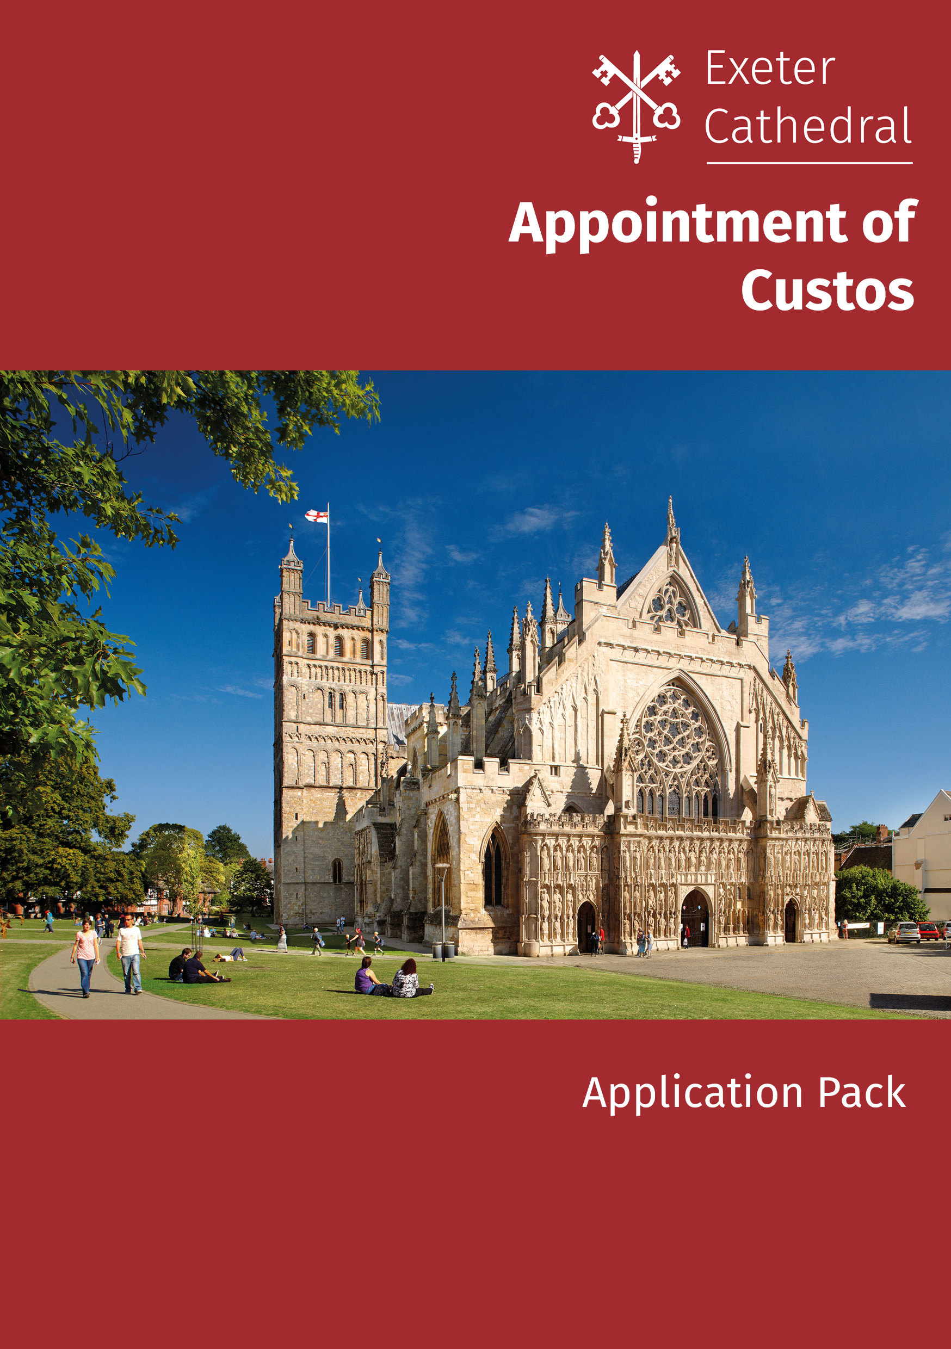
Custos
Contents

- About Exeter Cathedral page 3
- Job description and person specification page 5
- Summary Terms and Conditions page 7
- How to apply page 8

Background

Today’s tranquil setting hides a rich and at times troubled history. For Exeter Cathedral has survived 900 years of invasions, desecrations and religious disputes, some leading to the murder of its clergy. And its story goes back even further than the historic building which stands on the site today, to a Saxon minister which was built just metres away. Thanks to the archives and historic books in the Cathedral’s library, the full history of this remarkable building can be pieced together.

This Cathedral, like most other churches, is a building that tells a story. The story it tells, in stone and glass, architecture and layout, is the story of the Christian faith. It was built to be an expression on earth of the Kingdom of Heaven; it was also built to be an expression of the power of the Church and of those who built it; it was built to be, and remains today, a place of celebration, remembrance, and above all worship. But whatever the motivations of those who built and endowed it, whatever the motivations of those who come to visit, Exeter Cathedral is and remains a holy place.

Purposes and Values

Our Purpose
Exeter Cathedral exists for the glory of God and as a sign of God’s kingdom.

Our Mission
To grow in prayer, make disciples and serve people in Devon in Joy

We express this through daily worship and prayer, welcome and pastoral support, nurturing disciples, learning together and serving the community

How we do things is important and our values help us to focus our behaviours and expectations.

Our Values
Welcoming to all
The best we can be
Open and listening
Fair and respectful

Job Description - Custos

Job Summary
The role is to be the line manager of the Floor Supervisors and Virgers and to liaise with the Precentor and other Heads of Departments in the co-ordination and management of all activities, which take place within the Cathedral buildings.

Relationships
Report to: Cathedral Administrator

Responsible for: Floor Supervisors, Virgers, Seamstress, Cleaners

Key Relationships: Canon Precentor
Senior Management Team

Hours of Work: 35hrs per week based on a flexible working pattern (annualised hours of 1820 per year)

Location: Exeter Cathedral

Salary: Circa £32,000 without accommodation, £20,000 with rent free (only) accommodation

Duties:
- To have overall responsibility for the co-ordination of activities within the Cathedral and its buildings.
- To manage the Floor Supervisors, Virgers, cleaners and seamstress and review their performance to ensure they fulfil their roles and responsibilities effectively, and in a coherent, joined up manner
- To ensure that the Cathedral is secure, clean and in good order and to promote the highest standard and care of the vestries, plate, ornaments, vestments, chairs etc.
- To be responsible for drawing up the duty rota for Floor Supervisors and Virgers, ensuring correct cover at all times
- To attend the weekly Diary meeting, and carry out a diary briefing for relevant staff
- To ensure through the Sacristan, that the correct liturgical requirements are provided for services
- To be responsible through the Floor Supervisors, Sacristan and Virgers for the unlocking and locking of the buildings
- To support all users in complying with Cathedral Policies including Health & Safety and Safeguarding ensuring a safe environment for all staff, volunteers and visitors to the Cathedral
- To ensure all statutory paperwork and records are kept up to date
- In liaison with the Stewards, Guides and Sidesmen, to provide a welcome to visitors, pilgrims and worshippers
- To ensure the successful delivery of liturgical and sacristy duties for services
- Carry out a daily briefing for relevant staff and volunteers
- To liaise with the Events Office and act as a conduit for communication for all those working on the floor of the Cathedral and associated buildings; and to ensure the Cathedral is properly prepared for all events
- In conjunction with the Marketing staff to ensure that notices and displays meet the Cathedral requirements and are kept up to date.
- To ensure that decorum is maintained within the Cathedral at all times, and that services are not interrupted by noise from staff, visitors, works or outside
- To be responsible for the continual profession development of the Vigers, Sacristan, Floor Supervisors, Cleaning team and Seamstress.

Person Specification

Attributes | Essential | Desirable
Skills, Knowledge and Competencies
Experience of taking part in worship | X
Sympathy with aims and ethos of the Church of England or communicant member of Church of England | X
Proven leadership and management skills | X
Resilience and ability to stay calm when under pressure | X
Proven ability to manage/defuse conflict | X
An interest in historical building and history |  | X
Excellent planning and organisational skills and the ability to balance own work load | X
Effective communication – both written and oral | X
Experience of working with Volunteers |  | X
Experience of H & S |  | X
Ability to take instruction and direction | X
Experience of working with the public | X
A level of physical fitness and ability to work at height | X
Ability to manage a range of diverse tasks, sometimes working under pressure. | X
Ability to build good relationships with a diverse range of individuals and groups | X
Good team player but also a proven ability to lead a team | X
Strong IT skills (Word, Outlook, Excel) | X
Willingness to work flexible hours including early starts or late finishes | X
Previous experience of sound and technical equipment |  | X

Summary Terms and Conditions

Employment
The position of Custos is full-time 35hrs per week based on a flexible working pattern (annualised hours of 1820 per year)

Holidays
The holiday entitlement is 30 days per annum including bank holidays.

Probationary period
New employees are subject to the satisfactory completion of a six month probationary period. The Cathedral reserves the right to extend this period at its discretion.
The Cathedral will assess and review your work performance during this time and reserves the right to terminate your employment at any time during your probationary period.
During the first month of your employment, the Cathedral or you may terminate your employment without notice.
After one month's service and up to the satisfactory completion of your probationary period, including any extension to this, either party may terminate your employment by giving one month’s notice in writing

Parking
The cathedral currently provides free parking in the allocated parking spaces available for employees who travel to work by car on a first come first serve basis.

Safeguarding
The role requires an enhanced DBS check

How to Apply
If you have any queries or wish to discuss the role further please contact Catherine Escott vacancies@exeter-cathedral.org.uk or 01392 255573

Applications should be made to Catherine Escott either by email vacancies@exeter-cathedral.org.uk or by post marked confidential to

C Escott
Cathedral Administrator
Exeter Cathedral
1 The Cloisters
Exeter
EX1 1HS

Closing date for applications is Monday 27th May 2019

Interviews will be held on the morning of Wednesday 5th June 2019

Applications should take the form of:

- A completed application form, CV’s will not be accepted
- A supporting statement setting out
  - why you are interested in the role
  - what relevant experience you have to make you the ideal candidate for the role

